Monthly Report /2

- Date of Report:15/9/2025
- Student ID - Name: ISSAM AL AWAMLEH 21110241
- Major: CYBER SECRUITY
- Company: JODDB
- Department: cyber shield academy
- Industry Mentor: Ahmad ghneimat
- Apprenticeship Mentor: Shareef Shargawi
- Working days/hours:5 days (8AM-4PM)

Your report must cover these topics:
- Your role and responsibilities this month (+ evidence) :
My role is cyber security trainee and I was part of the projects in cyber shield for prepearing for C8 event with the usual tasks alongside with taking course in the academy it will next week (22/9/2025) and here’s my board:
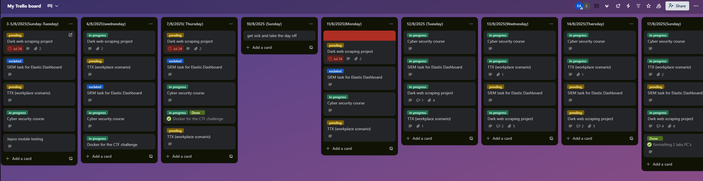
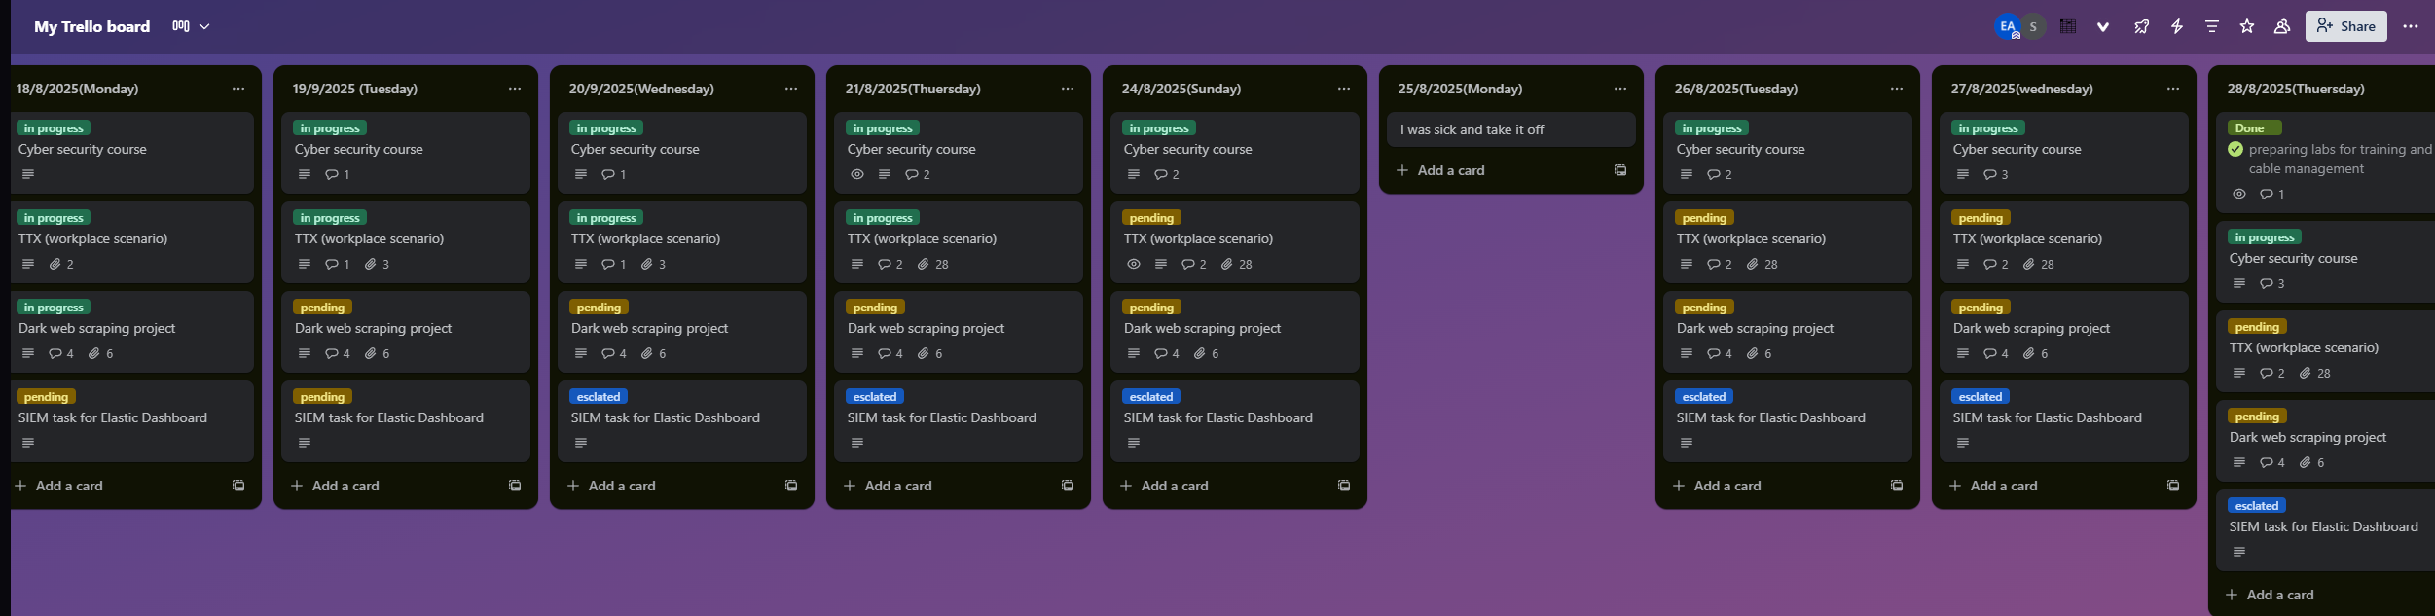
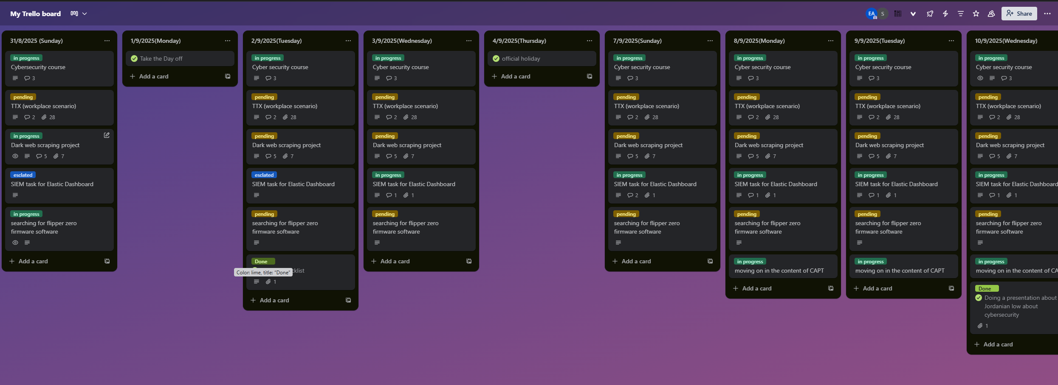
- Any problems / Challenges and how did you overcome them?
There was some problems but the apprenticeship team visited us and all the problems get solved.
The challenge was balancing between the work with the team and the course that I am taking and the perspective of my boss to achieve more than what I am achieving.

- Any training courses you attended during the apprenticeship, whether you opted for independently or through the employer.
  - Name of the course:cyber secuirty
  - Main Topics: cyber security foundations
  - Copy of certification: still in progress

  - Name of the course: CAPT certified associate penetration testing from Havkviser(individually)
  - Main Topics: Penetration testing
  - Copy of certification: still in progress
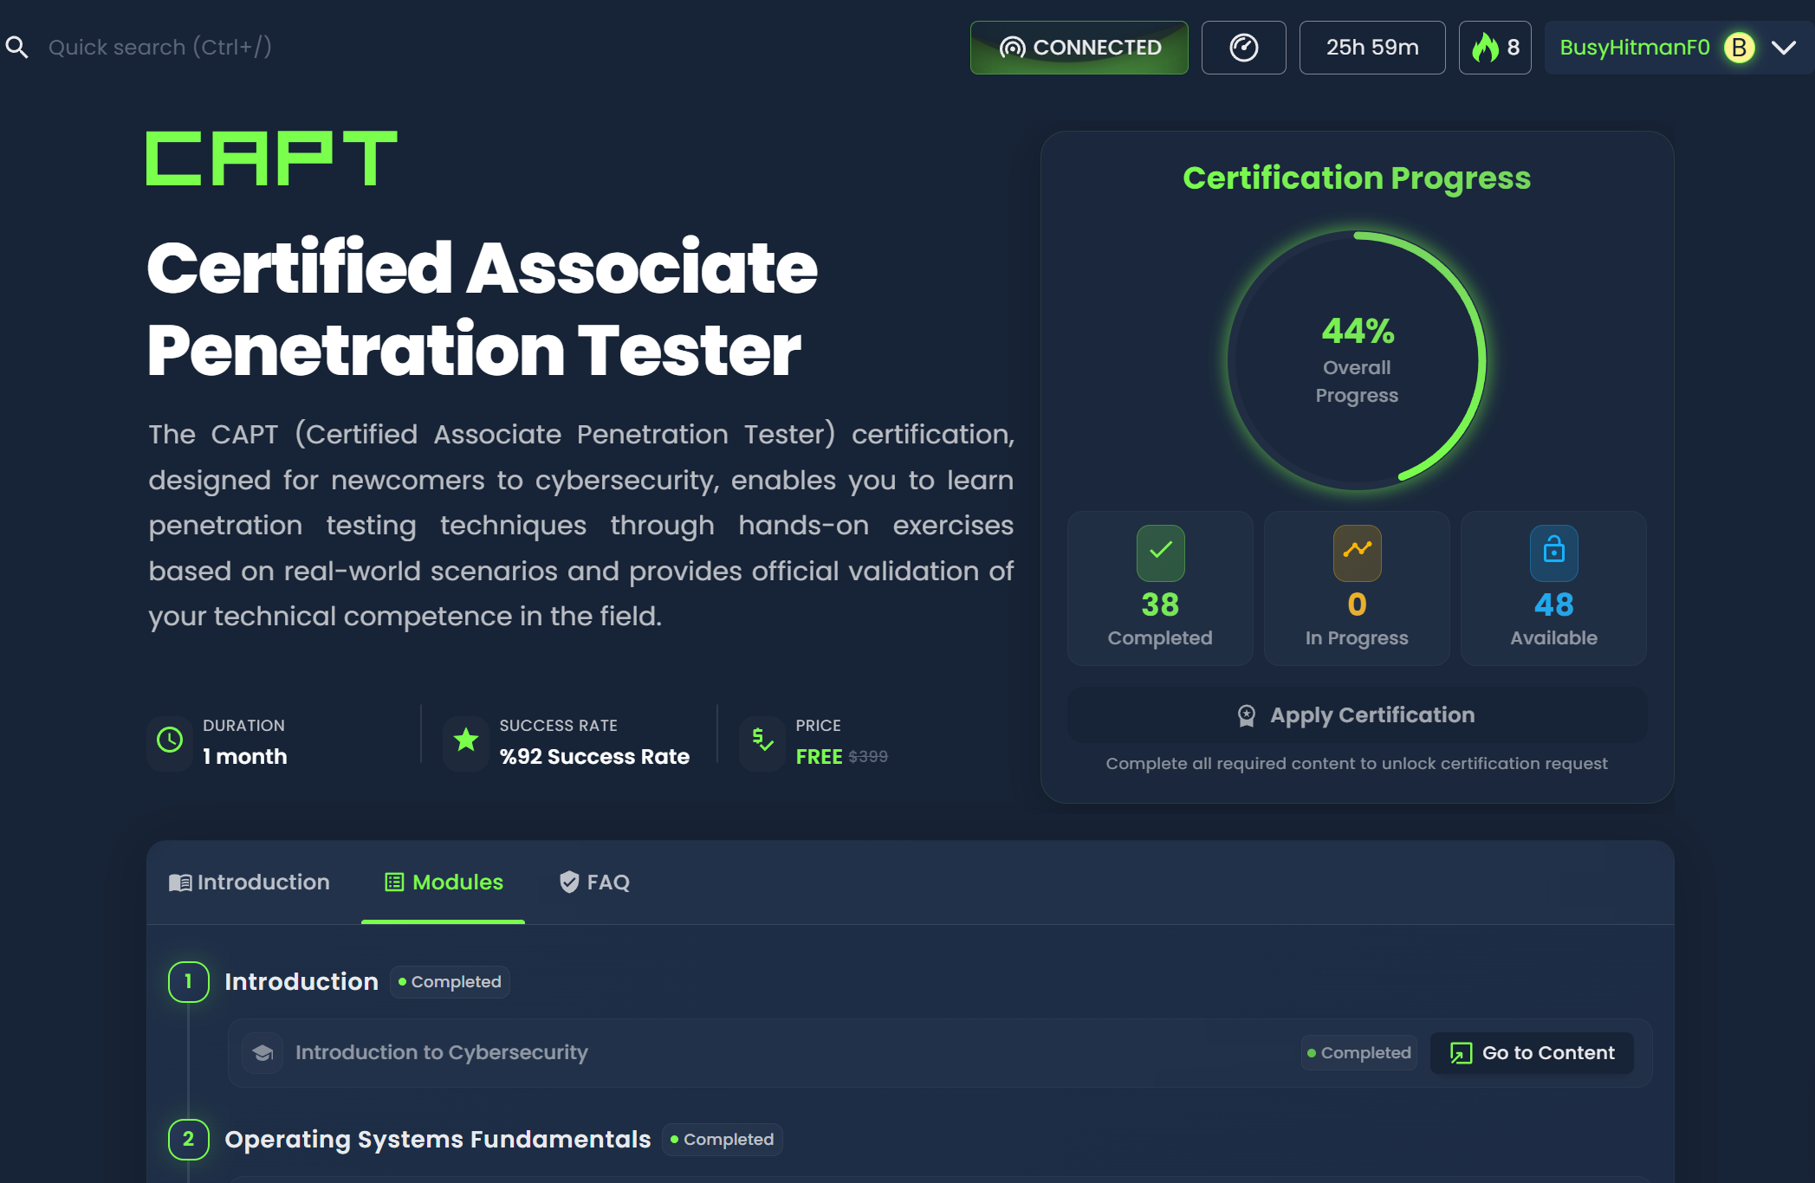

- What software /tools did you use?
Zeek, Logstash ,Kibana, elastic, Splunk, GitHub, fog project, volatility, virestotal,ffuf, gobuster, feroxbuster, replit , ISO 27001,NIST framework, COBIT19,hackviser, hack the box, dd, dc3dd, cyberchief,Darkweb, Tor ,flipper 0 , twinary,VMware, virtual box , ubuntu server, make ethernet cables (the whole process of wired strippers), Microsoft Word, Microsoft excel, python,VScode,katana,doing research about AWS cloud solutions and suricata.

- Technical and non-technical skills
Teamwork, research skill, analytic thinking, communication skills, Time management, problem solving,

- Did you work on the National Occupational Standards (NOSs):
  - How many NOSs did you complete out of 5?1/5
  - List of NOSs (Number (URN) – Name of NOS)
SEMPMO221 Contributing to effective team working

- Events / Conferences you participated in
None this month

- Your Plan for Next Month.
- Complete CAPT certification and get the next one which is CWSE(certified web security expert) it’s for free as well.
- If got a time I will start studying to my exam MCI Nutanix for cloud certification I got a voucher from the university.
- Start to get back to the work task’s and start finish them. Start tasks that related to C8 event.
- Building a great foundation and knowledge about Mobile PT.
- Trying to finish the TTX task because it’s become not on me it’s the responsibility of the whole team it should be done as soon as possible.

